HONG KONG INSTITUTE OF VOCATIONAL EDUCATION

## Laboratory 1: Create database and table

**Module Intended Learning Outcome (#3):**

On completion of the module, students are expected to be able to:

* Develop database queries to perform typical data definition and data manipulation operations in relational database systems.

## Lesson Intended Learning Outcome:

On completion of this lab, students are expected to be able to:

* Use a database client (Navicat) to interface with the DBMS (MySQL) and execute queries.
* Perform basic database operations (such as CREATE and INSERT) using Navicat.
* Generate and save CREATE statements for existing databases and tables within Navicat.

**In this section you will learn how to create a small database called Theme Park from the Entity Relationship Diagram (ERD) and Data dictionary.**

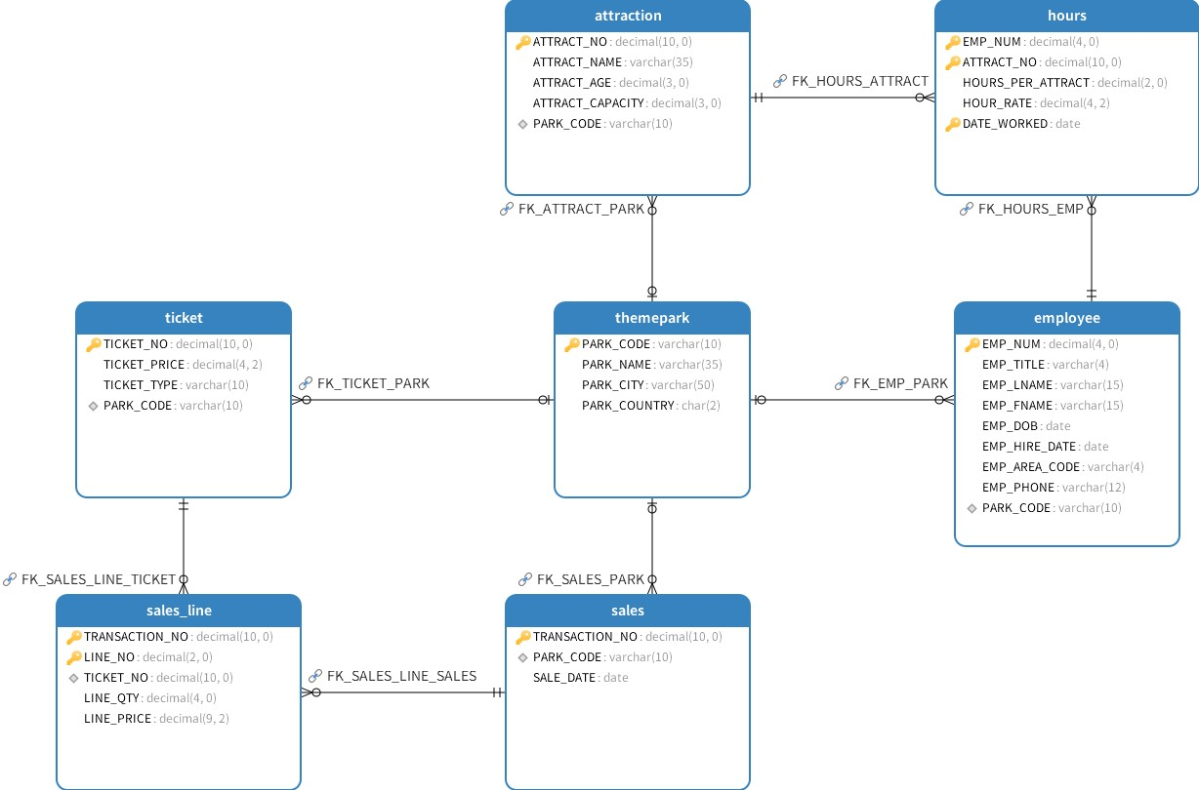

Figure Entity Relationship Diagram

# TASK:

1. Install and configure MySQL 8.0 and Navicat in your computer. Connect to MySQL database using Navicat.
2. Create a database called THEME_PARK
3. The table below shows the data dictionary for the **Theme_Park** database, which will be used to create each table structure.

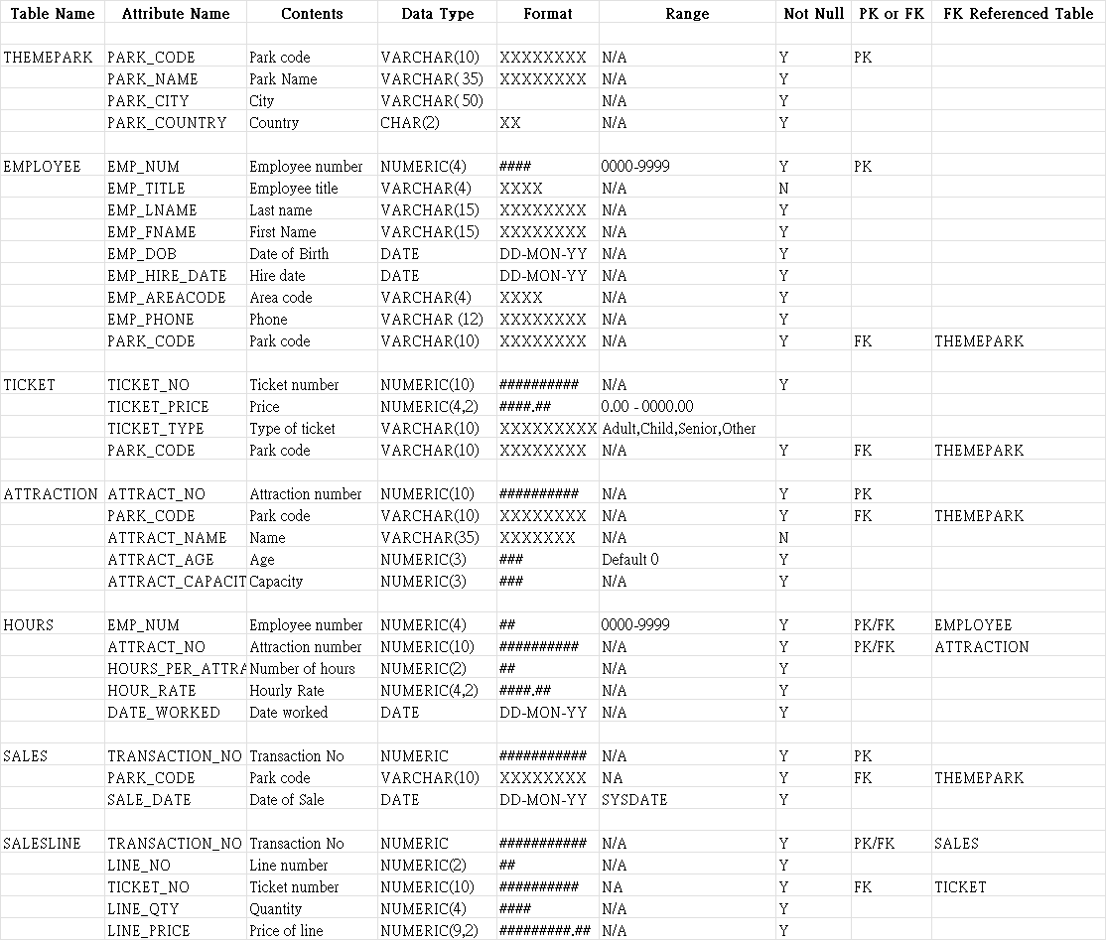

1. Create the table **THEMEPARK**.

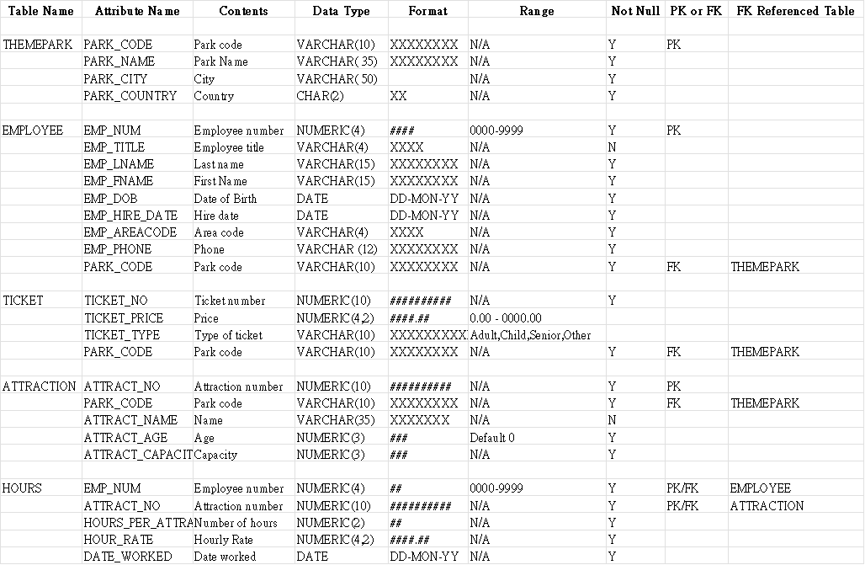

1. Display the CREATE TABLE Statement

The following query is used to get the CREATE TABLE statement for an existing table.

**SHOW CREATE TABLE THEMEPARK;**

Once the table is created, run it to confirms that the table has been created successfully with the specified columns and primary key.

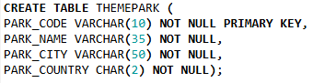

* The ENGINE and DEFAULT CHARSET values might vary depending on your database's configuration.

1. Insert the following records into the **THEMEPARK** table.

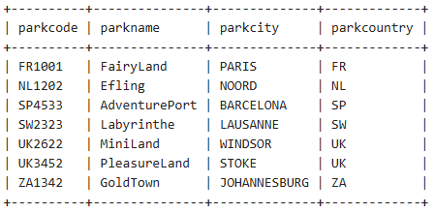

1. Create the table **EMPLOYEE** and provide the CREATE TABLE SQL statement.

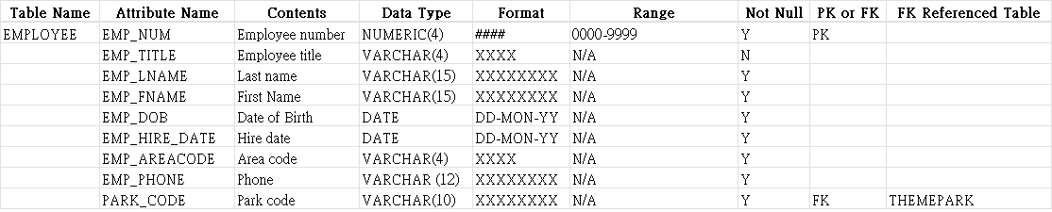

1. Insert the following records into the **Employee** table.

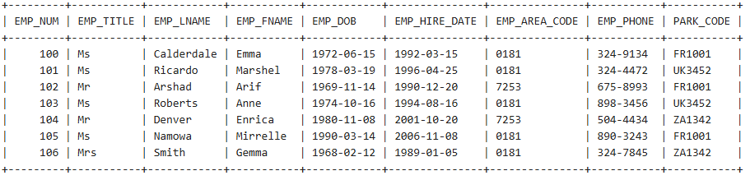

|  |
| --- |
| INSERT INTO EMPLOYEE VALUES (100,'Ms','Calderdale','Emma','1972-06-15','1992-03-15','0181','324-9134','FR1001');  INSERT INTO EMPLOYEE VALUES (101,'Ms','Ricardo','Marshel','1978-03-19','1996-04-25','0181','324-4472','UK3452');  INSERT INTO EMPLOYEE VALUES (102,'Mr','Arshad','Arif','1969-11-14','1990-12-20','7253','675-8993','FR1001');  INSERT INTO EMPLOYEE VALUES (103,'Ms','Roberts','Anne','1974-10-16','1994-08-16','0181','898-3456','UK3452');  INSERT INTO EMPLOYEE VALUES (104,'Mr','Denver','Enrica','1980-11-08','2001-10-20','7253','504-4434','ZA1342');  INSERT INTO EMPLOYEE VALUES (105,'Ms','Namowa','Mirrelle','1990-03-14','2006-11-08','0181','890-3243','FR1001');  INSERT INTO EMPLOYEE VALUES (106,'Mrs','Smith','Gemma','1968-02-12','1989-01-05','0181','324-7845','ZA1342'); |

1. Create the table **TICKET** and provide the CREATE TABLE SQL statement.

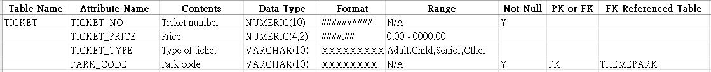

1. Insert the following records into the **TICKET** table.

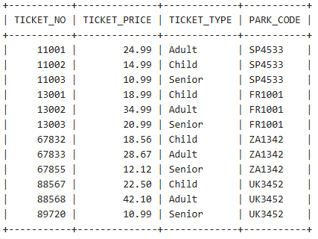

|  |
| --- |
| INSERT INTO TICKET VALUES (11001,24.99,'Adult','SP4533');  INSERT INTO TICKET VALUES (11002,14.99,'Child','SP4533');  INSERT INTO TICKET VALUES (11003,10.99,'Senior','SP4533');  INSERT INTO TICKET VALUES (13001,18.99,'Child','FR1001');  INSERT INTO TICKET VALUES (13002,34.99,'Adult','FR1001');  INSERT INTO TICKET VALUES (13003,20.99,'Senior','FR1001');  INSERT INTO TICKET VALUES (67832,18.56,'Child','ZA1342');  INSERT INTO TICKET VALUES (67833,28.67,'Adult','ZA1342');  INSERT INTO TICKET VALUES (67855,12.12,'Senior','ZA1342');  INSERT INTO TICKET VALUES (88567,22.50,'Child','UK3452');  INSERT INTO TICKET VALUES (88568,42.10,'Adult','UK3452');  INSERT INTO TICKET VALUES (89720,10.99,'Senior','UK3452'); |

1. Create the table **ATTRACTION** and provide the CREATE TABLE SQL statement

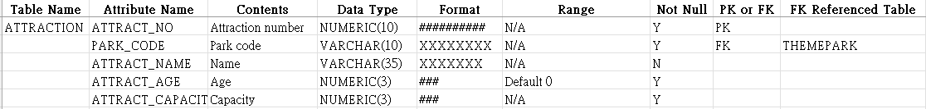

1. Insert the following records into the **ATTRACTION** table.

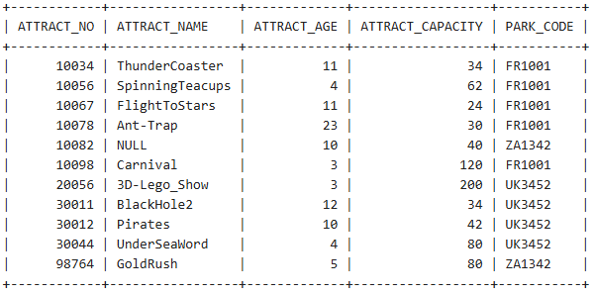

|  |
| --- |
| INSERT INTO ATTRACTION VALUES (10034,'ThunderCoaster',11,34,'FR1001');  INSERT INTO ATTRACTION VALUES (10056,'SpinningTeacups',4,62,'FR1001');  INSERT INTO ATTRACTION VALUES (10067,'FlightToStars',11,24,'FR1001');  INSERT INTO ATTRACTION VALUES (10078,'Ant-Trap',23,30,'FR1001');  INSERT INTO ATTRACTION VALUES (10098,'Carnival',3,120,'FR1001');  INSERT INTO ATTRACTION VALUES (20056,'3D-Lego_Show',3,200,'UK3452');  INSERT INTO ATTRACTION VALUES (30011,'BlackHole2',12,34,'UK3452');  INSERT INTO ATTRACTION VALUES (30012,'Pirates',10,42,'UK3452');  INSERT INTO ATTRACTION VALUES (30044,'UnderSeaWord',4,80,'UK3452');  INSERT INTO ATTRACTION VALUES (98764,'GoldRush',5,80,'ZA1342');  INSERT INTO ATTRACTION VALUES (10082,NULL,10,40,'ZA1342'); |

1. Create the table **HOURS** and provide the CREATE TABLE SQL statement

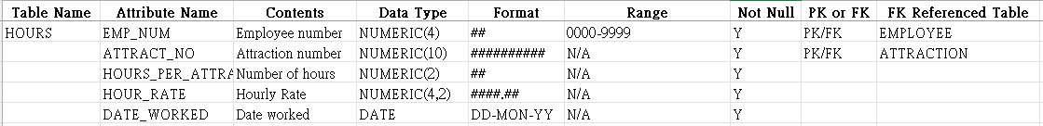

1. Insert the following records into the **HOURS** table.

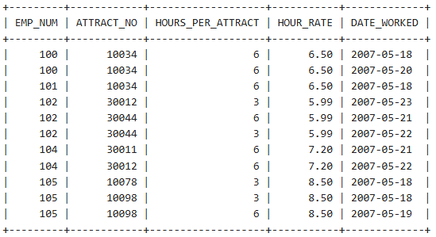

|  |
| --- |
| INSERT INTO HOURS VALUES (100,10034,6,6.5,'2007-05-18');  INSERT INTO HOURS VALUES (100,10034,6,6.5,'2007-05-20');  INSERT INTO HOURS VALUES (101,10034,6,6.5,'2007-05-18');  INSERT INTO HOURS VALUES (102,30012,3,5.99,'2007-05-23');  INSERT INTO HOURS VALUES (102,30044,6,5.99,'2007-05-21');  INSERT INTO HOURS VALUES (102,30044,3,5.99,'2007-05-22');  INSERT INTO HOURS VALUES (104,30011,6,7.2,'2007-05-21');  INSERT INTO HOURS VALUES (104,30012,6,7.2,'2007-05-22');  INSERT INTO HOURS VALUES (105,10078,3,8.5,'2007-05-18');  INSERT INTO HOURS VALUES (105,10098,3,8.5,'2007-05-18');  INSERT INTO HOURS VALUES (105,10098,6,8.5,'2007-05-19'); |

1. Create the table **SALES** and provide the CREATE TABLE SQL statement



1. Insert the following records into the **SALES** table.

|  |  |
| --- | --- |
|  | INSERT INTO SALES VALUES (12781,'FR1001','2007-05-18');  INSERT INTO SALES VALUES (12782,'FR1001','2007-05-18');  INSERT INTO SALES VALUES (12783,'FR1001','2007-05-18');  INSERT INTO SALES VALUES (12784,'FR1001','2007-05-18');  INSERT INTO SALES VALUES (12785,'FR1001','2007-05-18');  INSERT INTO SALES VALUES (12786,'FR1001','2007-05-18');  INSERT INTO SALES VALUES (34534,'UK3452','2007-05-18');  INSERT INTO SALES VALUES (34535,'UK3452','2007-05-18');  INSERT INTO SALES VALUES (34536,'UK3452','2007-05-18');  INSERT INTO SALES VALUES (34537,'UK3452','2007-05-18');  INSERT INTO SALES VALUES (34538,'UK3452','2007-05-18');  INSERT INTO SALES VALUES (34539,'UK3452','2007-05-18');  INSERT INTO SALES VALUES (34540,'UK3452','2007-05-18');  INSERT INTO SALES VALUES (34541,'UK3452','2007-05-18');  INSERT INTO SALES VALUES (67589,'ZA1342','2007-05-18');  INSERT INTO SALES VALUES (67590,'ZA1342','2007-05-18');  INSERT INTO SALES VALUES (67591,'ZA1342','2007-05-18');  INSERT INTO SALES VALUES (67592,'ZA1342','2007-05-18');  INSERT INTO SALES VALUES (67593,'ZA1342','2007-05-18'); |

1. Create the table **SALES_LINE** and provide the CREATE TABLE SQL statement

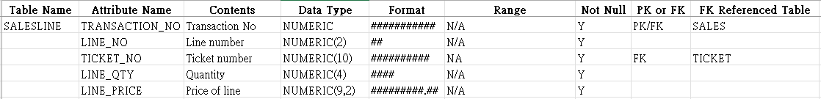

1. Insert the following records into the **SALES_LINE** table.

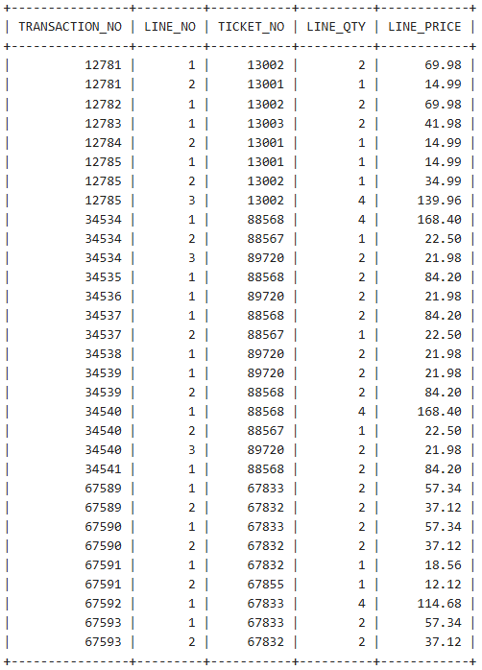

|  |  |
| --- | --- |
| INSERT INTO SALES_LINE VALUES (12781,1,13002,2,69.98);  INSERT INTO SALES_LINE VALUES (12781,2,13001,1,14.99);  INSERT INTO SALES_LINE VALUES (12782,1,13002,2,69.98);  INSERT INTO SALES_LINE VALUES (12783,1,13003,2,41.98);  INSERT INTO SALES_LINE VALUES (12784,2,13001,1,14.99);  INSERT INTO SALES_LINE VALUES (12785,1,13001,1,14.99);  INSERT INTO SALES_LINE VALUES (12785,2,13002,1,34.99);  INSERT INTO SALES_LINE VALUES (12785,3,13002,4,139.96);  INSERT INTO SALES_LINE VALUES (34534,1,88568,4,168.40);  INSERT INTO SALES_LINE VALUES (34534,2,88567,1,22.50);  INSERT INTO SALES_LINE VALUES (34534,3,89720,2,21.98);  INSERT INTO SALES_LINE VALUES (34535,1,88568,2,84.20);  INSERT INTO SALES_LINE VALUES (34536,1,89720,2,21.98);  INSERT INTO SALES_LINE VALUES (34537,1,88568,2,84.20);  INSERT INTO SALES_LINE VALUES (34537,2,88567,1,22.50);  INSERT INTO SALES_LINE VALUES (34538,1,89720,2,21.98);  INSERT INTO SALES_LINE VALUES (67593,2,67832,2,37.12); | INSERT INTO SALES_LINE VALUES (34539,1,89720,2,21.98);  INSERT INTO SALES_LINE VALUES (34539,2,88568,2,84.20);  INSERT INTO SALES_LINE VALUES (34540,1,88568,4,168.40);  INSERT INTO SALES_LINE VALUES (34540,2,88567,1,22.50);  INSERT INTO SALES_LINE VALUES (34540,3,89720,2,21.98);  INSERT INTO SALES_LINE VALUES (34541,1,88568,2,84.20);  INSERT INTO SALES_LINE VALUES (67589,1,67833,2,57.34);  INSERT INTO SALES_LINE VALUES (67589,2,67832,2,37.12);  INSERT INTO SALES_LINE VALUES (67590,1,67833,2,57.34);  INSERT INTO SALES_LINE VALUES (67590,2,67832,2,37.12);  INSERT INTO SALES_LINE VALUES (67591,1,67832,1,18.56);  INSERT INTO SALES_LINE VALUES (67591,2,67855,1,12.12);  INSERT INTO SALES_LINE VALUES (67592,1,67833,4,114.68);  INSERT INTO SALES_LINE VALUES (67593,1,67833,2,57.34); |

END